PROJECT 3, ECONOMIC FORECASTING
STUDENTS NAME
INSTITUTIONAL AFFILIATION

Project 3
Option 1: economic forecasting
Introduction
Economic forecasting is the process of attempting to predict the future condition of the economy using a combination of important and widely followed indicators. Before investing , informed economists would want to determine how productive the investment is going to be. This means determining the potential. Economic forecasting is done by using three variables of the economy which are: gross domestic product (GDO), inflation rate and the rate of unemployment in a particular country. These factors are responsible for the health of any economy all over the world.
Gross domestic product, is used to measure the economic growth of the economy over time. When the GDP of a country is high, the economy is said to be growing and when the GDP is low, the economy is said to be struggling.
Inflation rate, when the prices of commodities are rising each and every day, the country is said to be undergoing inflation. This rise in prices reduces the ability of people to purchase goods and services produced and thus impacting negatively on the economy.
The rate of unemployment determines how fast the econ0omy grows. Labor is a primary factor of production, when a higher percentage of people are engaged in productive opportunities, the economy is sure to grow unlike when a higher percentage of people are without any productive labor.
Methodology
To determine the health of the economy, it would be necessary to observe the trends in the economic variables over a considerable period of time preferably one financial year. This entails comprehensive study of data from the United States bureau of analysis
The findings of the data analysis on GDP, inflation rate and unemployment rate are:
Gross domestic product
In the first quarter of 2021, real gross domestic product (GDP) increased at an annual pace of 6.4 percent, reflecting sustained economic recovery, establishments reopening, and government reaction to the COVID-19 epidemic. The pace of increase was identical to the “second” estimate given in May. The Corona virus Response and Relief Supplemental Appropriations Act and the American Rescue Plan Act distributed government assistance payments to households and businesses in the first quarter, including direct economic impact payments, expanded unemployment benefits, and Paycheck Protection Program loans. Real GDP climbed by 4.3 percent in the fourth quarter of 2020. Personal consumption expenditures (PCE), nonresidential fixed investment, federal government spending, residential fixed investment, and state and local government spending all increased in the first quarter, partially offset by losses in private inventory investment and exports. (K Barefoot, 2018)
The rate of unemployment
In June 2021, the US unemployment rate rose to 5.9%, unchanged from May's 14-month low but still significantly over pre-pandemic levels, as the number of unemployed individuals rose by 168 thousand to 9.48 million, while employment levels declined by 18 thousand to 151.60 million. At 61.6 percent, the labor force participation rate remained steady. Despite the high rate of vaccination and continuous government support, the labor market has continued to show indications of recovery, aided by broader economic re-opening. Employers around the country have been complaining about the difficulty in filling open positions, citing continued labor shortages as a result of increased benefits, concerns about contracting COVID-19, and difficulty in finding qualified candidates. The data is shown in the graph below.
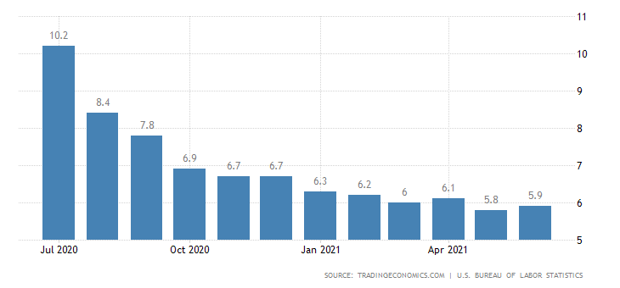
The inflation rate
The inflation rate in America in 2020 was approximated to 1.4% and this negative inflation was greatly attributed to the covid-19 effect. This was a reduction from 2.3% in 2019 which saw the economy grow. The inflation rate for 2021 up to June was approximated to be 1.8 which is an increase from 2020. This is positive inflation which is healthy for business people and consumers.
Analysis of findings and discussion. The Report.
Having shown consistent data on the GDP of the United States, the rate at which the economy has grown over the past twelve months is quite considerable. Despite the effects of a global pandemic, the economy is pulling through. Investing the fabric business would assure productivity since the consumer price index is high. When the GDP is rising, it would be expected that the people have enough purchasing power and the government tariffs are favorable for business. Therefore it would be a good time to invest in the United States. (PA Balland, 2020)

The rate of unemployment over the past twelve months has slightly increased. This has been fueled globally by covid-19 pandemic. Therefore, a considerable number of people are with skills but without any productive labor. This situation works for the investor positively and negatively. Firstly, after investing in fabric business the investor is assured of labor availability in the United States. Centrally to that, unemployment would mean that some people do not have the comfortable purchasing power which can be a hindrance to the investor. However, data from the GDP has shown increased growth rate in American economy and this means that the unemployment rate can only serve as an advantage in terms of labor other than a disadvantage. (D Farrell, 2020)
The rate of inflation is average in the United States in the past twelve months. This is what is called walking inflation and is only good for business people and consumers because it matches demand and supply in the market. Therefore from information on inflation rate, it is only the ripe time to invest in the United States of America. (CH Zhang, 2020)
Conclusion and recommendation
Based on the facts shown above, there are two strong factors that promote the need to invest in fabric business in America and these are: favorable GDP and inflation rate. The unemployment rate has equal advantage and disadvantage and therefore the question of whether or not to invest in the United States, the answer would be the time is now.

References

CH Zhang, G. S. (2020). Spatial disparities in coronavirus incidence and mortality in the United States: an ecological analysis as of May 2020. The Journal of Rural Health, 2020 , 6.
D Farrell, P. G. (2020). Consumption effects of unemployment insurance during the covid-19 pandemic. Available at SSRN , 4.
K Barefoot, D. C. (2018). Defining and measuring the digital economy. The Bureau of Economic Analysis , 15.
PA Balland, C. J.-F. (2020). Complex economic activities concentrate in large cities. Nature Human , 5.

